**SEWAGE PIPELINE BLOCKAGE DETECTION USING FEATURE EXTRACTION**

## INTRODUCTION:

* In some countries Sewer networks are one of the most important networks. These networks are responsible for draining away both waste water and also rain water in order to maintain hygiene of the communities and in order to limit the spread of disease.
* Today, cities and towns are facing problems in maintaining the sewage system. Even though few countries banned the practice of manual scavenging , government agencies still use thousands of manual scavengers to clean drains.

## PROBLEM STATEMENT:

* Sewer blockage problem is increasing due to the high use of polythene bags and also other solid materials which are dumped into sewer systems.
* This leads to frequent choking or blocking of sewer lines, which results in sanitation problems and health hazards.
* Research on sewer pipe inspection and blockage detection is carried all over the world.
* The main problem is improper inspection and maintenance of sewer network.

## OBJECTIVE:

To automatically detect the defects and blockage in a sewer pipeline from inspection images and videos by image processing using SVM technique. Few images are taken for training and histogram of those images is found. Whenever an input image is given 250 pixels of that image are extracted and compared with the histogram generated from the trained images. Feature extraction is used to find whether the sewer pipeline is blocked or not. Using SVM the image can be classified as no blockage, blockage due to roots and blockage due to sediment.

## METHODOLOGY:

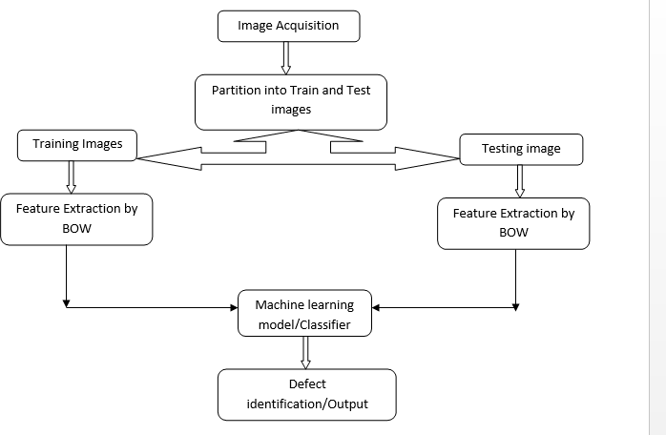

**CODE:**

%% Load image data

% This assumes you have a directory: defects_category

% with each scene in a subdirectory

imds = imageDatastore(fullfile(matlabroot,'Defects detection','Pipe_defects',{'No blockage','Roots','Sediment formation'}),...

'LabelSource','foldernames','FileExtensions',{'.jpg',}) %#ok

%% Display Class Names and Counts

tbl = countEachLabel(imds) %#ok categories = tbl.Label;

%% Display Sampling of Image Data sample = splitEachLabel(imds,6);

montage(sample.Files(1:6)); title(char(tbl.Label(1)));

%% Show sampling of all data for ii = 1:3

sf = (ii-1)*6 +1;

ax(ii) = subplot(2,2,ii); montage(sample.Files(sf:sf+3)); title(char(tbl.Label(ii)));

end

%% Partition 10 images for training and 4 for testing

%%[training_set, test_set] = prepareInputFiles(imds);

%% Create Visual Vocabulary

tic

bag = bagOfFeatures(training_set,... 'VocabularySize',250,'PointSelection','Detector');

defectsdata = double(encode(bag, training_set)); toc

return;

%% Visualize Feature Vectors

img = read(training_set(1), randi(training_set(1).Count)); featureVector = encode(bag, img);

subplot(4,2,1); imshow(img); subplot(4,2,2);

bar(featureVector);title('Visual Word Occurrences');xlabel('Visual Word Index');ylabel('Frequency');

img = read(training_set(2), randi(training_set(2).Count)); featureVector = encode(bag, img);

subplot(4,2,3); imshow(img); subplot(4,2,4);

bar(featureVector);title('Visual Word Occurrences');xlabel('Visual Word Index');ylabel('Frequency');

img = read(training_set(3), randi(training_set(3).Count)); featureVector = encode(bag, img);

subplot(4,2,5); imshow(img); subplot(4,2,6);

bar(featureVector);title('Visual Word Occurrences');xlabel('Visual Word Index');ylabel('Frequency');

%%

categoryClassifier = trainImageCategoryClassifier(training_set, bag);

%%

confMatrix = evaluate(categoryClassifier,training_set);

%%Trying the Newly Trained Classifier on Test Images

%%

img = imread('root4.jpg'); imshow(img)

[labelIdx, scores] = predict(categoryClassifier, img); categoryClassifier.Labels(labelIdx)

## RESULTS:

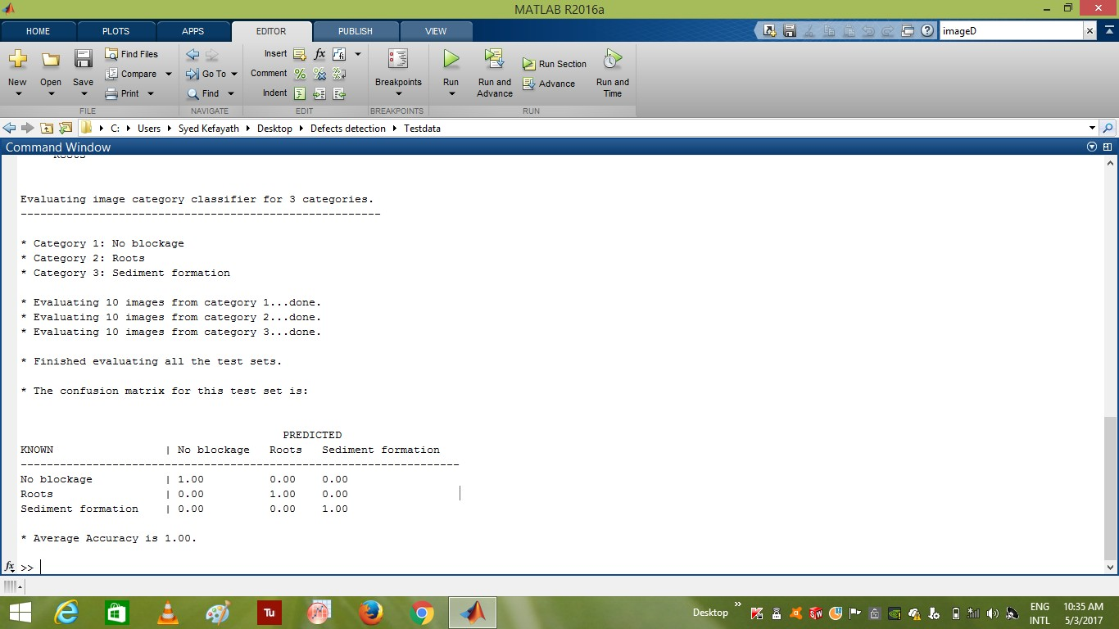

Montage/Sample of Input image datastore for features extraction and training

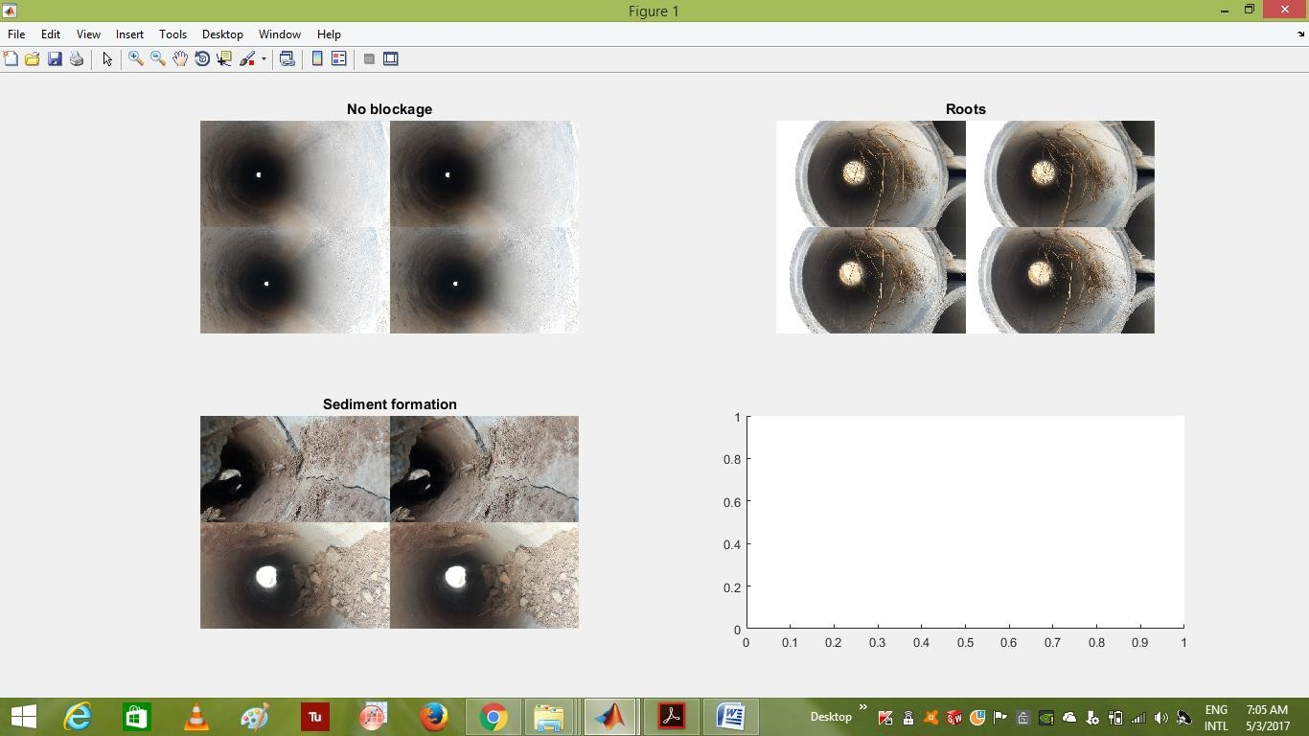

Histogram of the input images

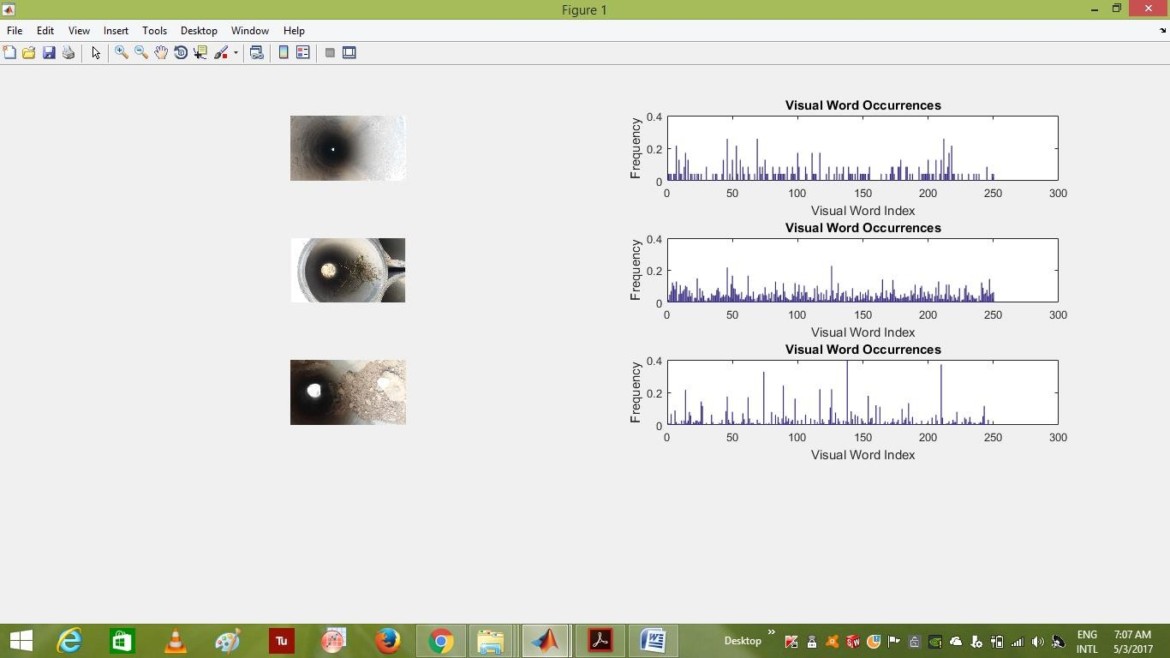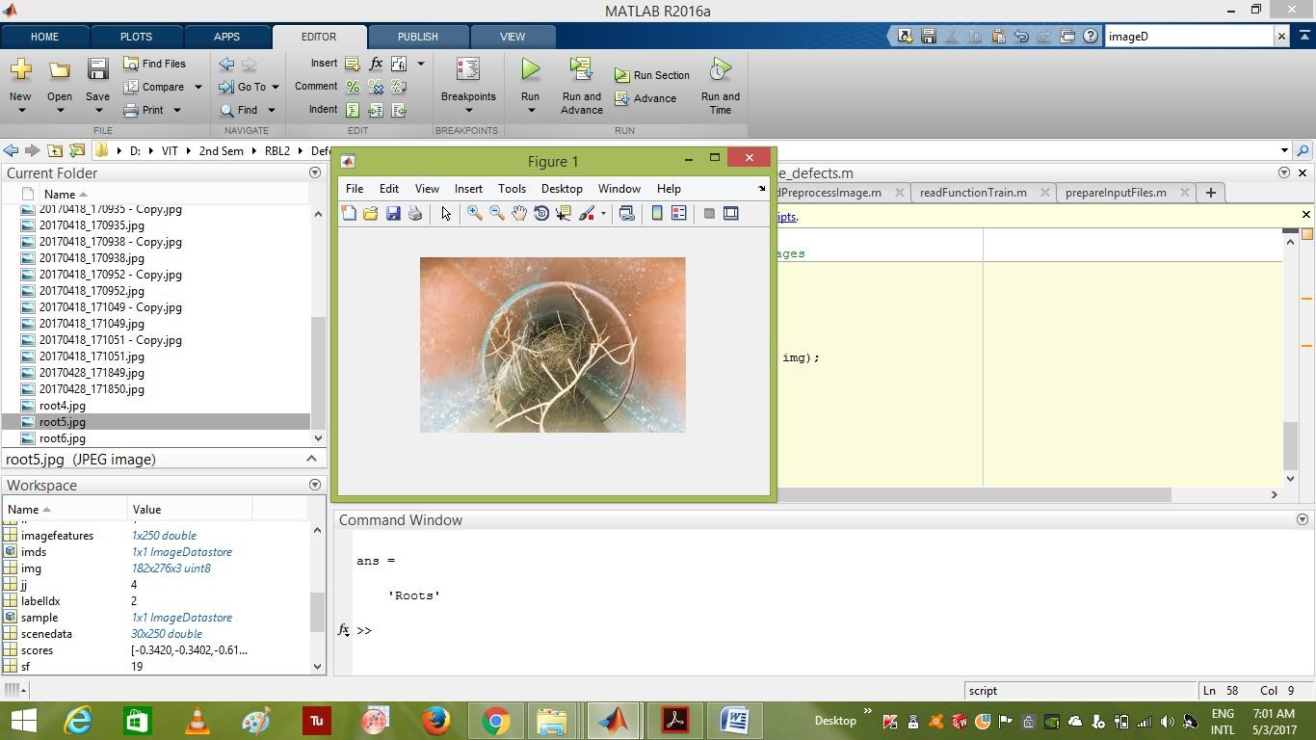

Fig : Output =detection of root in the image

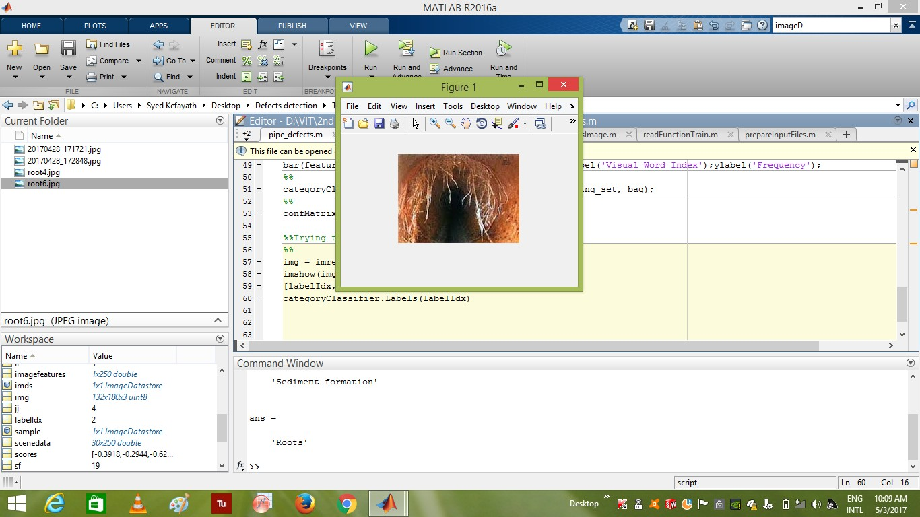

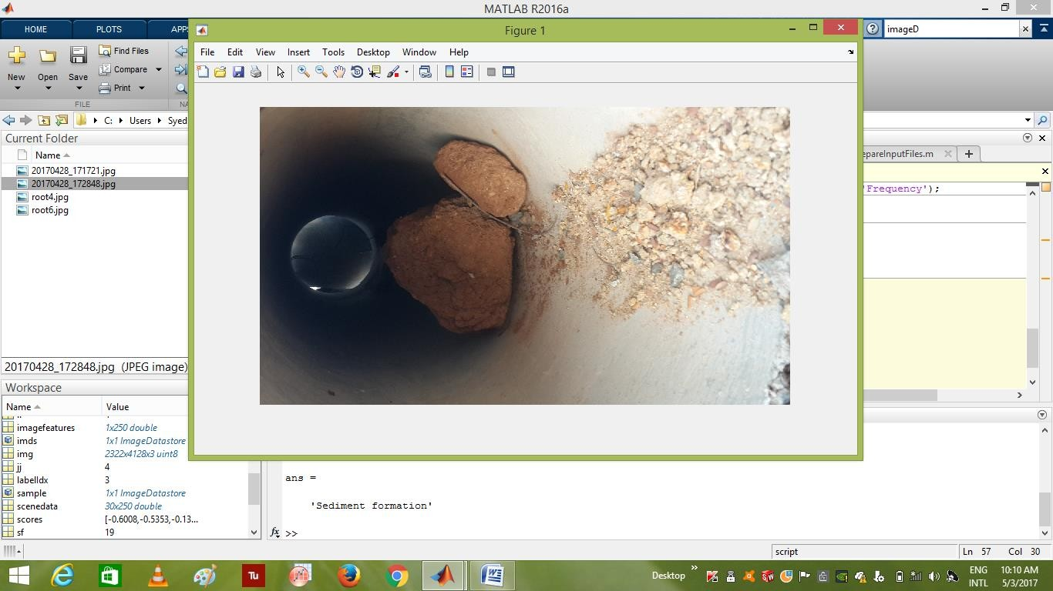

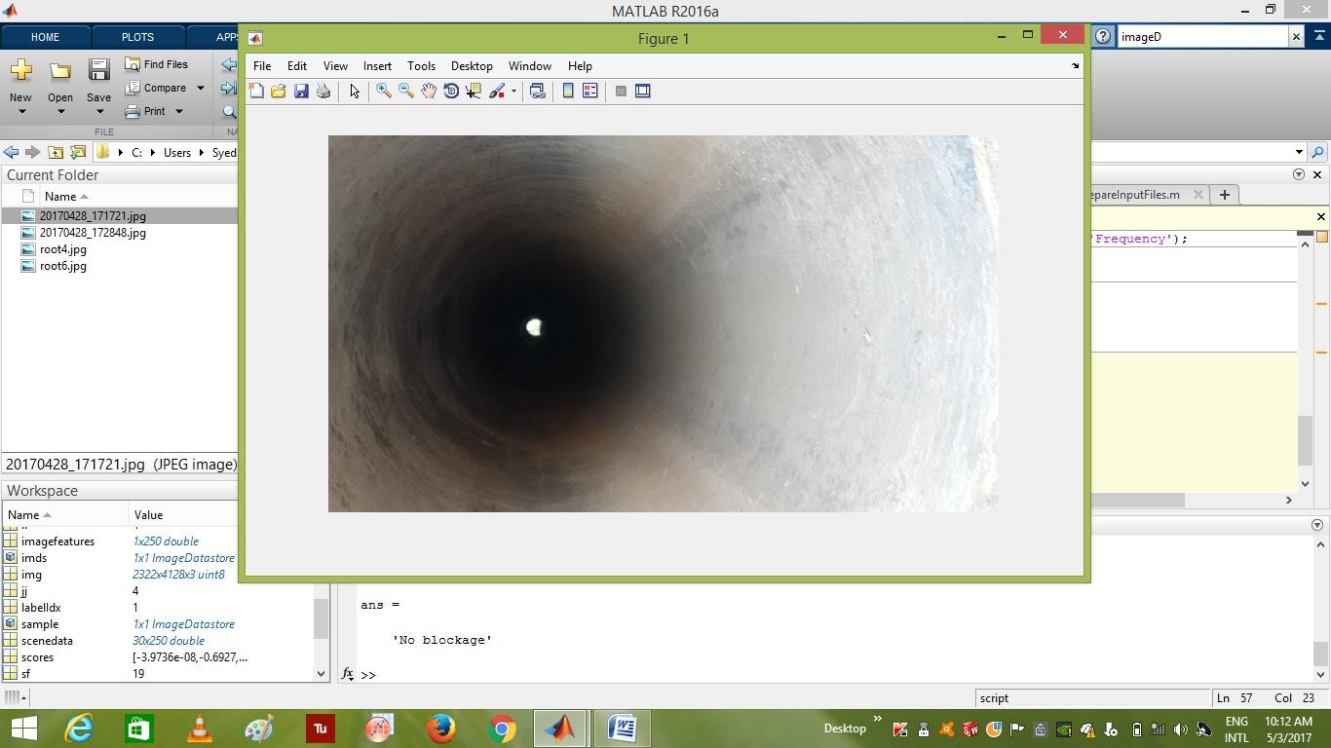

## CONCLUSION:

The identification of the block on a sewage pipeline can be done using feature extraction technique and the input mage is classified as no blockage, roots and sediments using SVM algorithm.